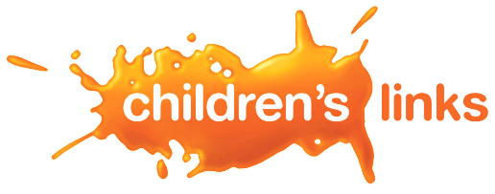
Modern Slavery Statement
Last reviewed: July 2025
MODERN SLAVERY
1 . We do not tolerate slavery or human trafficking in any part of our business and are committed to ensuring that it does not take place in our supply chains.
2. Our anti-slavery policy reflects our aim to act transparently, respectfully and with integrity in all our business relationships. We implement and enforce effective systems and controls to mitigate this risk.
3. We have reviewed our purchases to understand the nature of our suppliers. These include freelancers, consultants and companies providing a wide range of goods and services to help us deliver our aims and objectives.
4. We have in place systems to mitigate the risk of slavery and human trafficking occurring in our supply chains, allowing us to assess, identify, address and monitor risk areas. We assess the risk of slavery or human trafficking occurring in our supply chains and apply enhanced checks where higher-risk areas are identified.
5. To ensure a high level of understanding of the risks of modern slavery and human trafficking in our supply chains and our business, we provide updates to our staff via our intranet and internal newsletters/briefings and by providing both written and oral reminders of good practice.
This statement forms part of our HR Handbook and was approved by the Board of Trustees when last amended in July 2023. It is supported by our policies around Equity, Diversity and Inclusion, Finance, HR, Recruitment and Safeguarding.
Actions we have taken in the last year include:
- Added Modern Slavery to our required training list
- Provided a Modern Slavery training session for 92 staff at our whole team day
- Strengthened references in other policies
- Improved our due diligence checks around Modern Slavery
- Improved our reporting around Modern Slavery, including adding a new KPI
Our assessment has identified no high-risk areas within our business and supply chains. There have been no concerns reported relating to Modern Slavery.

